Test Plan

**Requirements:**

1. **Support latest IE (II) and Chrome (39)**
2. **Basic read only interface**
3. **Table shown as in below:**

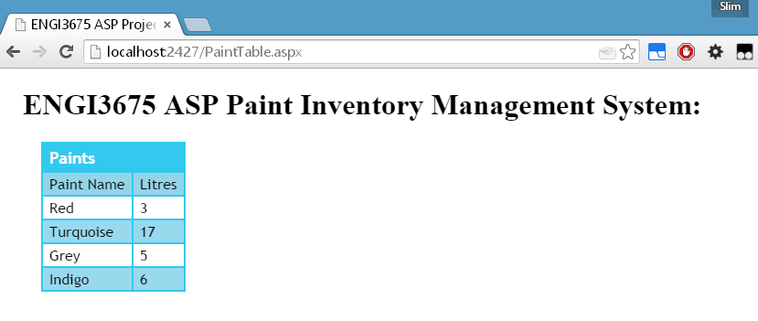

**Manual Test:**

1. Visit <http://localhost:2427/PaintTable.aspx> in both Internet explorer V11 and Chrome V39 and ensure connection and configuration of the webserver is correct. (GET request does not result in http 404 error).
2. Ensure Table is shown as in Figure 1 using the correct stylesheet.
3. Table should contain the 4 entries listed in the PRD shown in Figure 1.

**Unit Test (Database):**

1. Run the WebApplication3UNItest named Database test.
2. If the connection to the database succeeds and all the expected values are present, the test indicate that it has passed



1. Failed tests will show up and a more detailed explanation of the error can be in the output as shown on the following page.

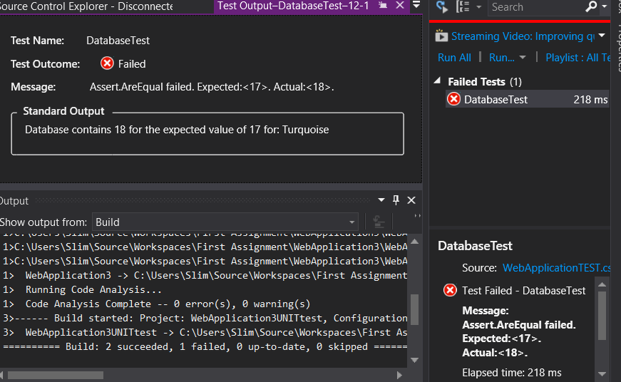

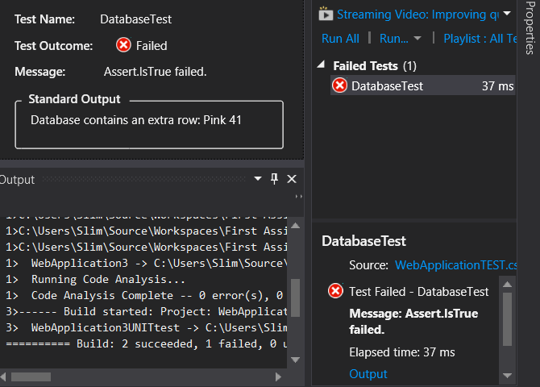

**Integration Test (Selenium):**

Prerequisites

* Selenium 2.44.0
* Chrome, Internet Explorer and Firefox Webdrivers

For simplicity the integration test was built into the UnitTest Project.

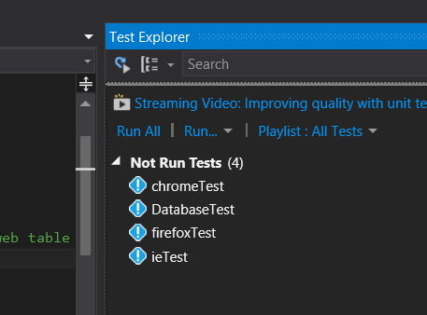

1. Ensure the project has been published and that the IIS webserver is running
2. Run all or choose the test you would like to run.